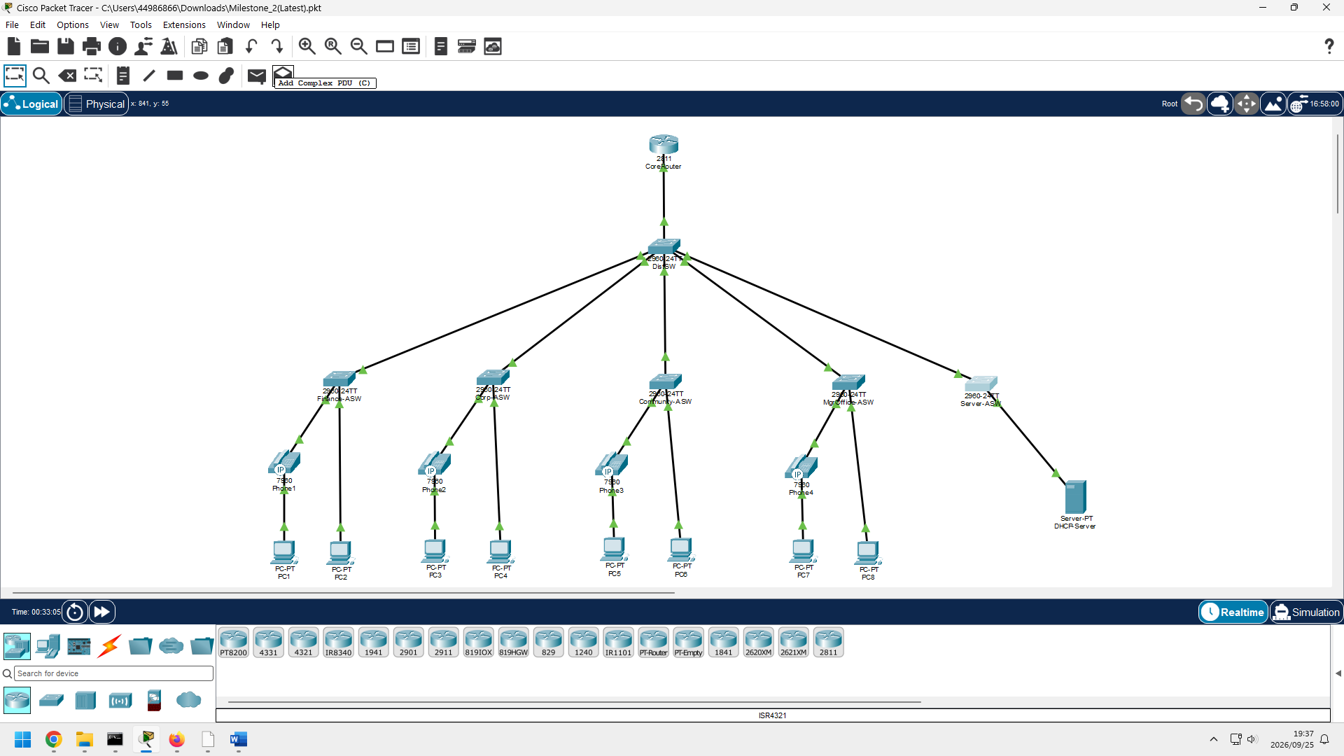
Figure 1: Topology-cabled

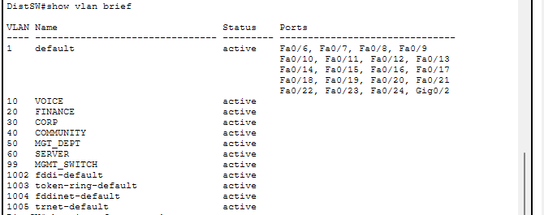
Figure 2:DistSW-verify (vlan brief)

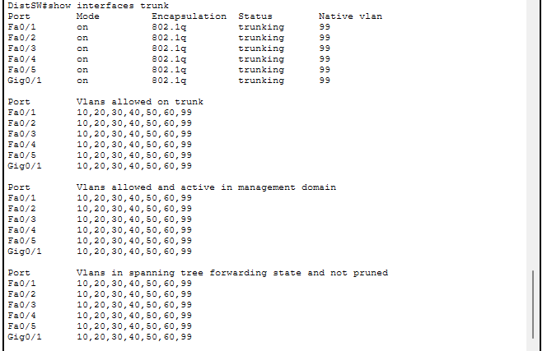
Figure 3:DistSW-verify (trunk interfaces)

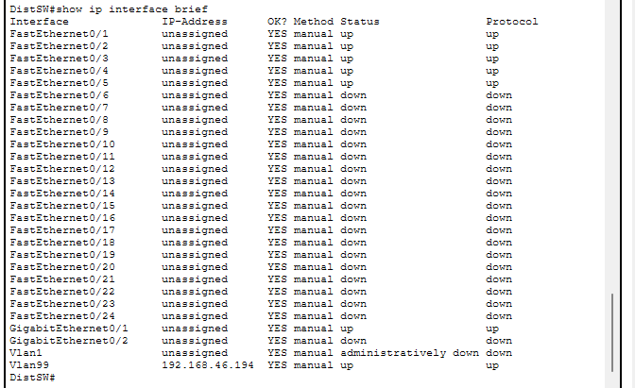
Figure 4:DistSW-verify (ip interface)
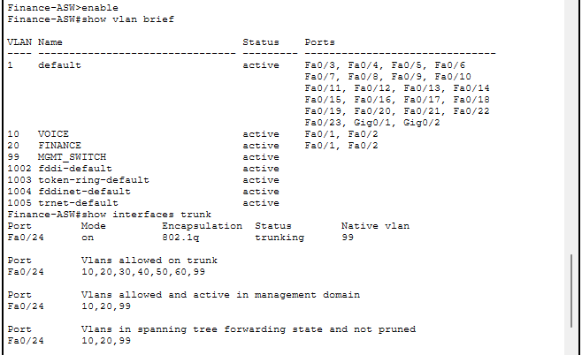
Figure 5:Finance-ASW-verify (vlan brief)

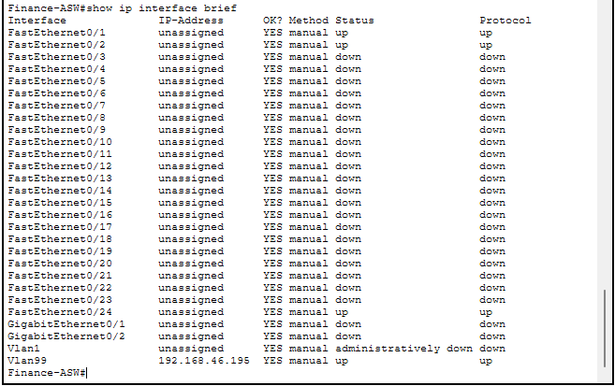
Figure 6:Finance-ASW-verify (ip interface)
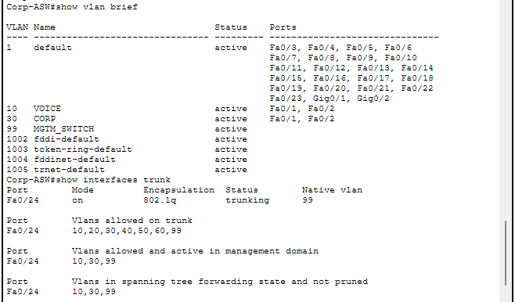
Figure 7:Corp-ASW-verify (vlan brief)

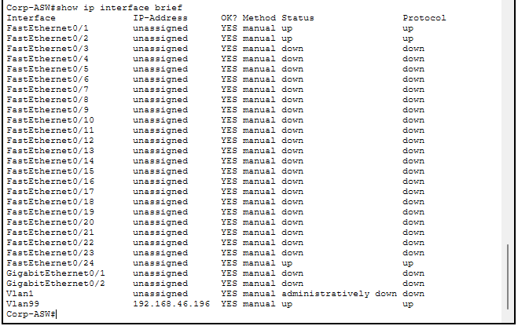
Figure 8:Corp-ASW-verify (ip interface)

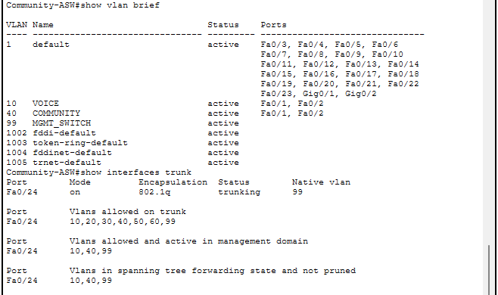
Figure 9:Community-ASW-verify (vlan brief)

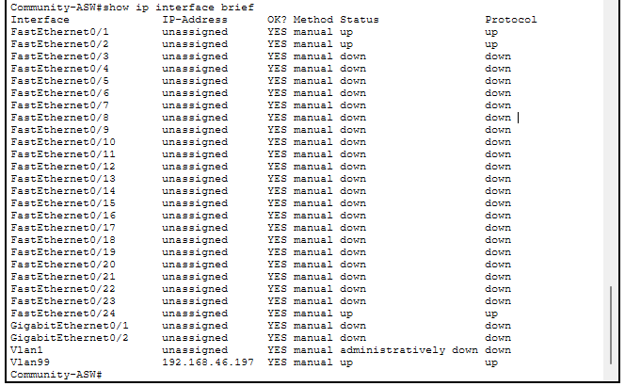
Figure 10:Community-ASW-verify (ip interface)

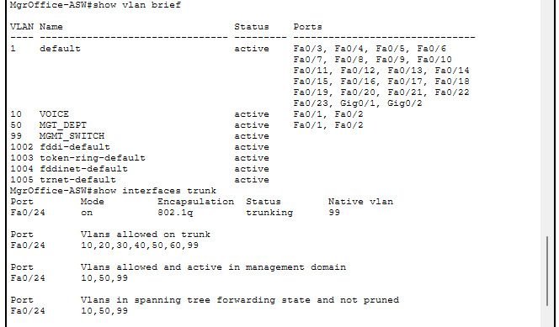
Figure 11:MgrOffice-ASW-verify (vlan brief)

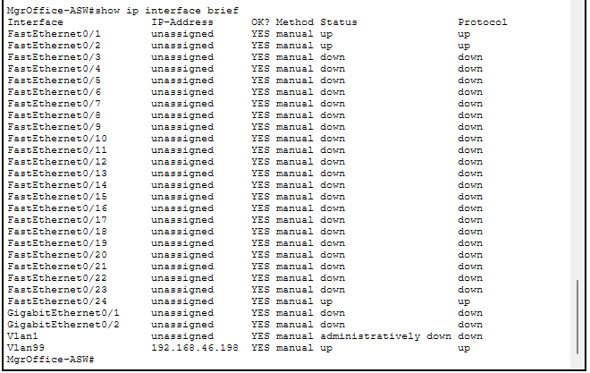
Figure 12:MgrOffice-ASW-verify (ip interface)

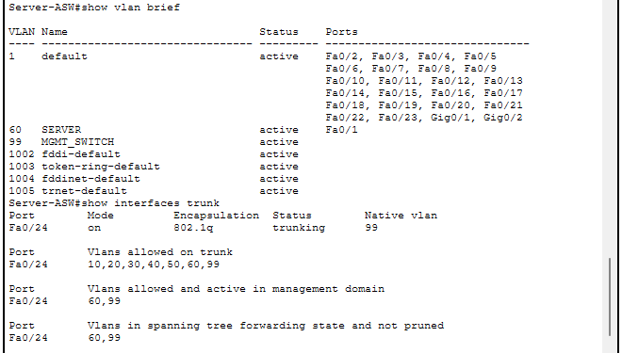
Figure 13:Server-ASW-verify (vlan brief)

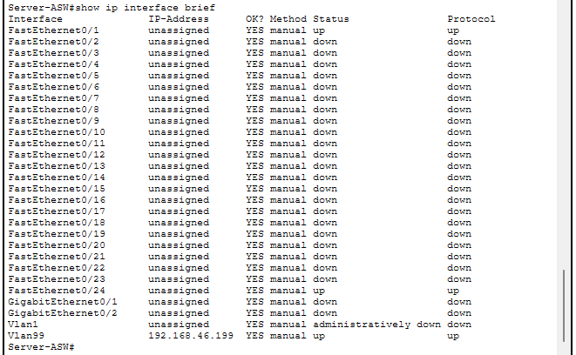
Figure 14:Server-ASW-verify (ip interface)

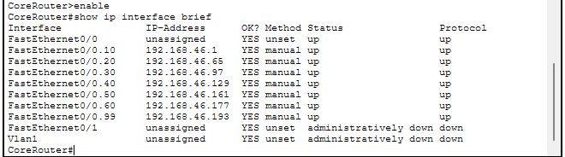
Figure 15:Router-sub-interfaces

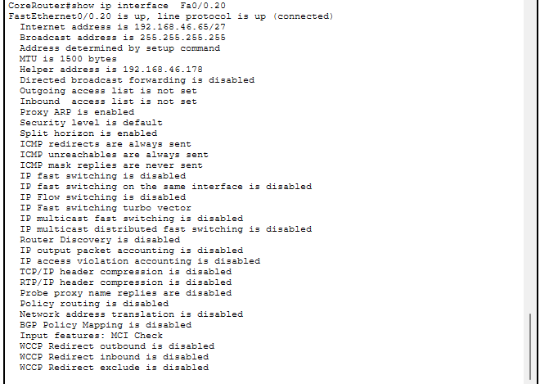
Figure 16:Router-dhcp-relay

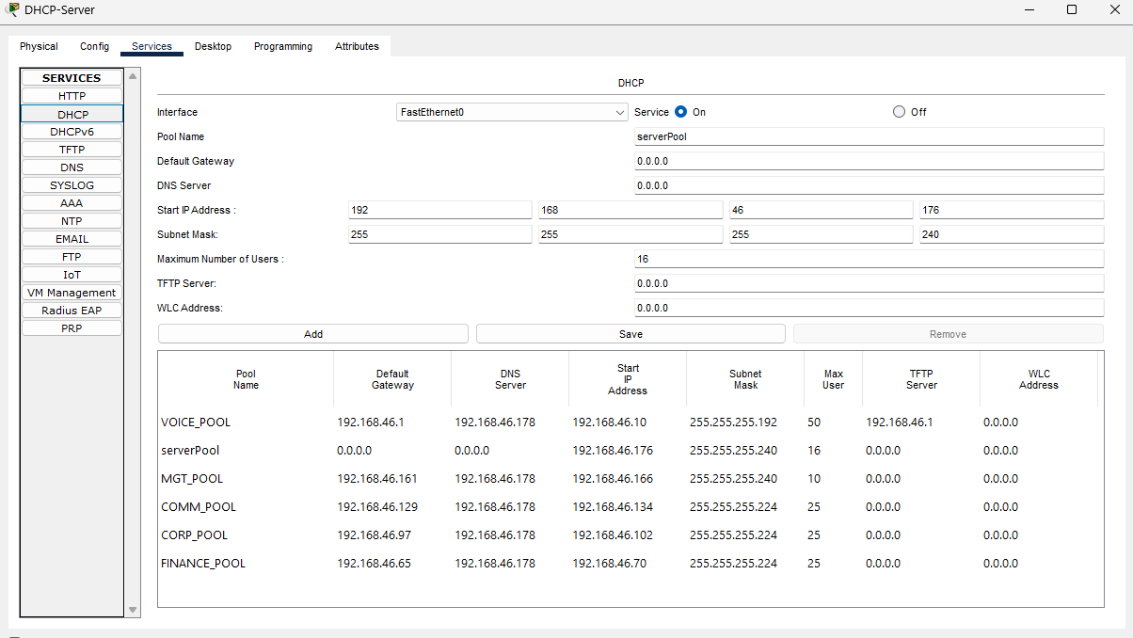
Figure 17:dhcp-pools
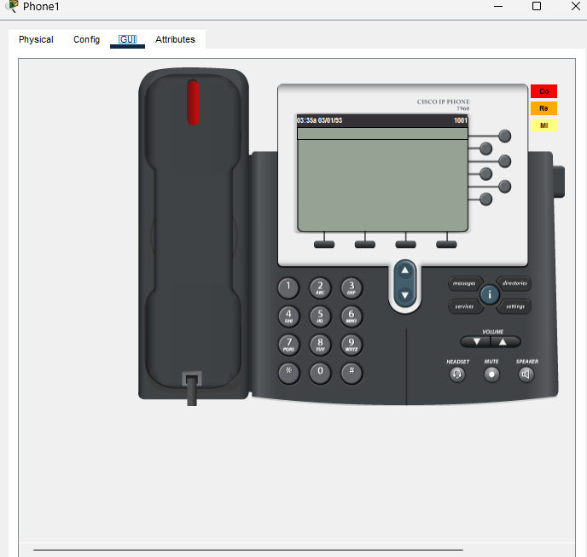
Figure 18:phone1-registered
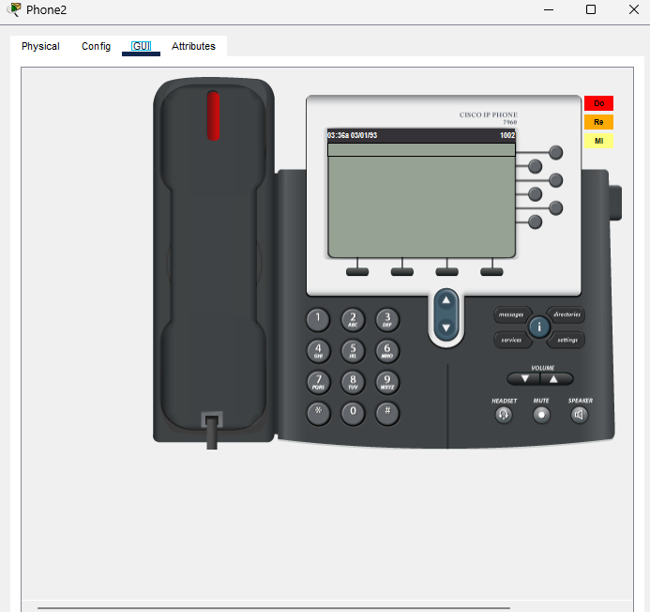
Figure 19:phone2-registered
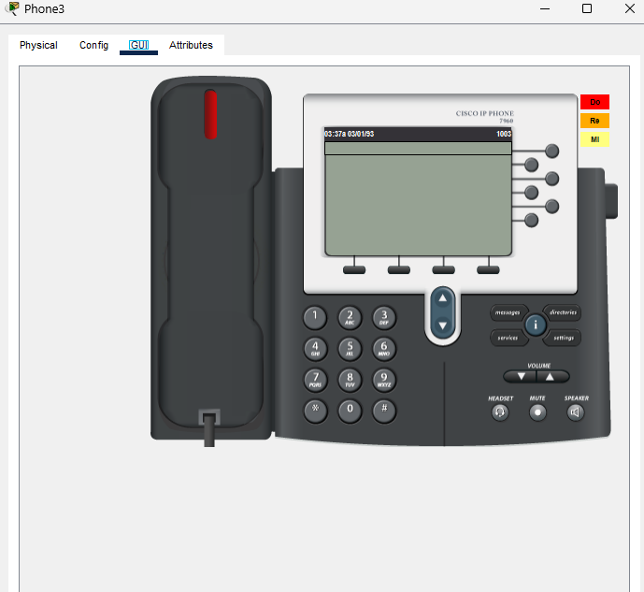
Figure 20:phone3-registered
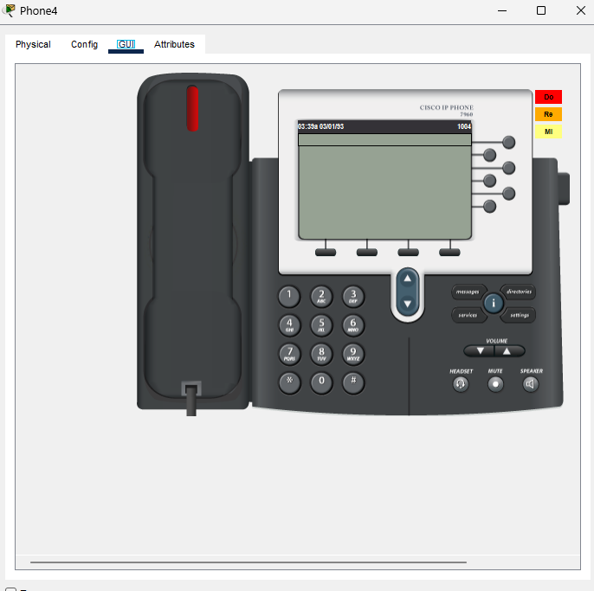
Figure 21:phone4-registered

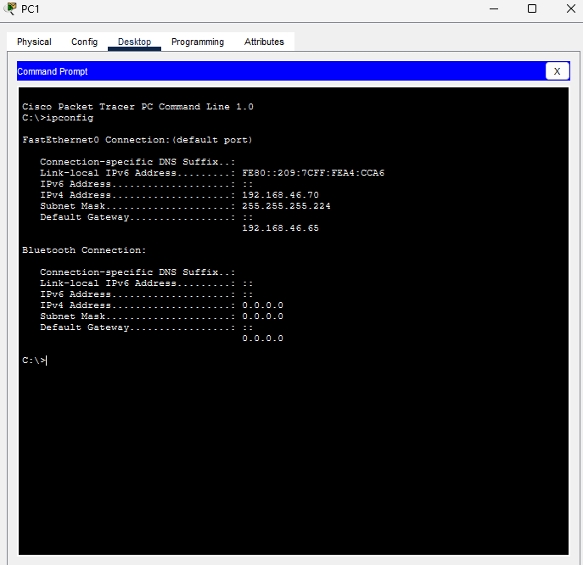
Figure 22:dhcp-pc1

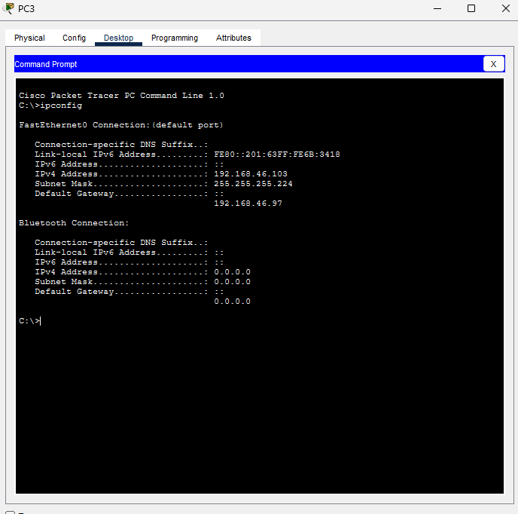
Figure 23:dhcp-pc3

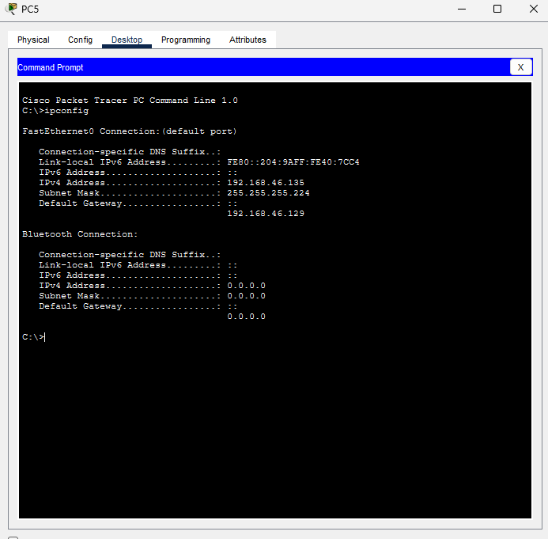
Figure 24:dhcp-pc5

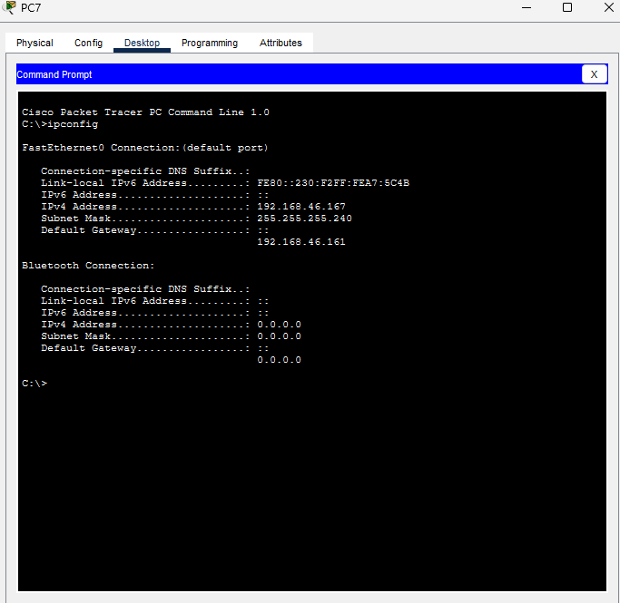
Figure 25:dhcp-pc7

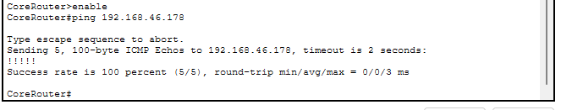
Figure 26:server-reachable
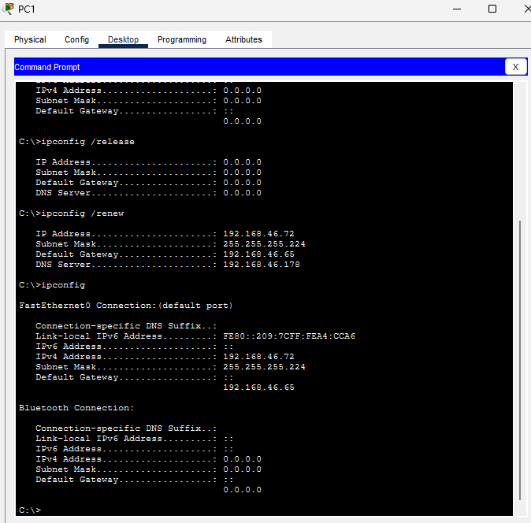
Figure 27:dhcp-renew

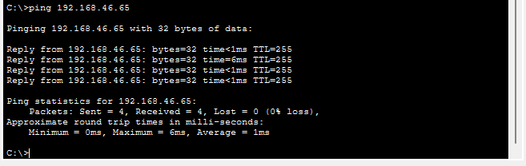
Figure 28:ping-gateway
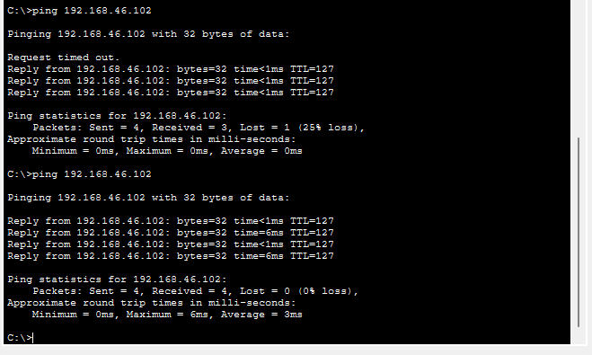
Figure 29:ping-inter-vlan

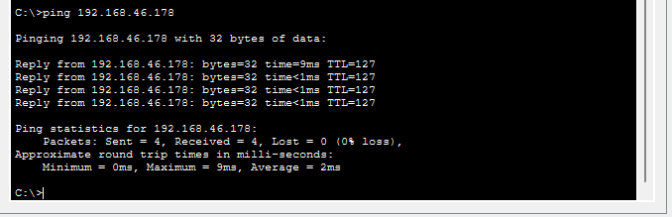
Figure 30:ping-server

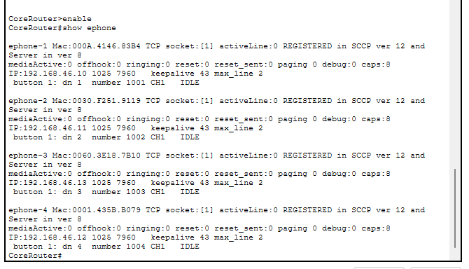
Figure 31:ephone-registered

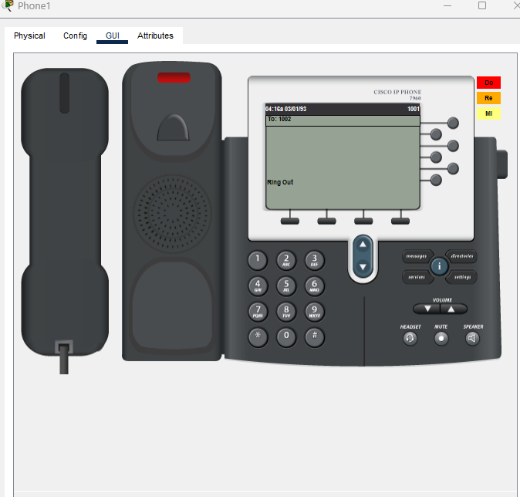
Figure 32:VoIP-call-test-part-1

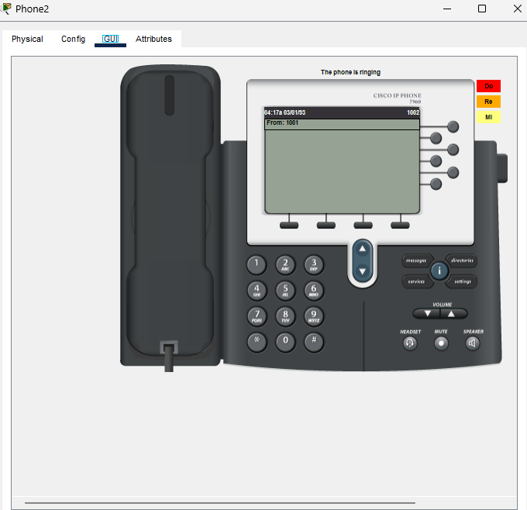
Figure 33:VoIP-call-test-part-2

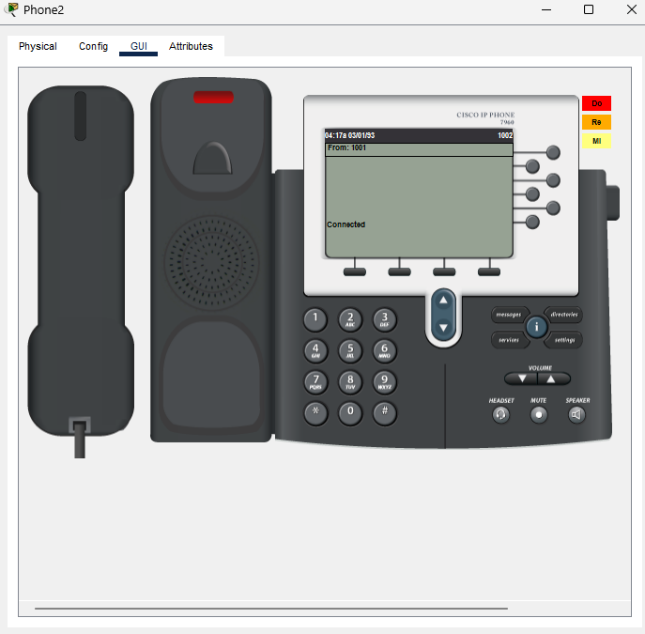
Figure 34:VoIP-call-connected

